LIVE OAK
ELEMENTARY
2021 – 2022
STUDENT HANDBOOK

Dear Parents,

Welcome to the 2021 – 2022 school year at Live Oak Elementary. As you read through this handbook with your child, please take the time to discuss all policies, including our EAGLE rules, dress code, PBIS information, and Title I Involvement Policy.
This handbook provides general information that will help both you and your child become more familiar with our policies and procedures at Live Oak Elementary. We are looking forward to an exciting school year full of educational opportunities and making memories together. Please know that we understand, as educators, the valuable role that we have in each student’s life. We appreciate your support and know that together, we can accomplish amazing things!
Michelle Crochet
Principal
Live Oak Elementary

Live Oak Elementary
2021 – 2022 Student Handbook

Principal: Michelle Crochet
Asst. Principal: Kenya Wells
Instructional Coach: Wendi Dupont
Counselor: Denise Gautreaux

Physical Address: Live Oak Elementary
35194 Old La. Hwy 16
Denham Springs, La. 70706

Mailing Address: Live Oak Elementary
P.O. Box 620
Watson, La. 70786

Phone Numbers: School Office: (225) 665-6702
Fax Number: (225) 664-7910
Cafeteria: (225) 664-9385

Website: www.liveoakelementary.com
Follow us on Facebook & Twitter @OakWatson

School Mission Statement
Everyone Achieves Goals while Learning and Encouraging all Students.

School Motto
Aim High
Work Hard
Dream BIG!
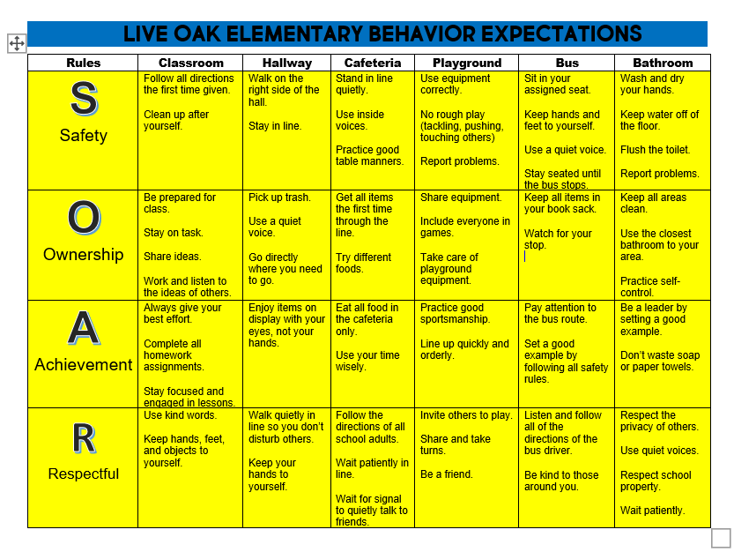

VISION
Live Oak Elementary is a student-centered school where we focus on empowering students to help them to grow to the highest level possible. It is a safe place where students want to be to learn and grow. It’s a place where all staff members develop long-lasting relationships with the students, so they are eager to take educational risks. LOE includes a staff of motivated educators who possess a mindset of continuous learning. Our goal is to form relationships with parents and the community so that together, we are able to develop 21st century learners.

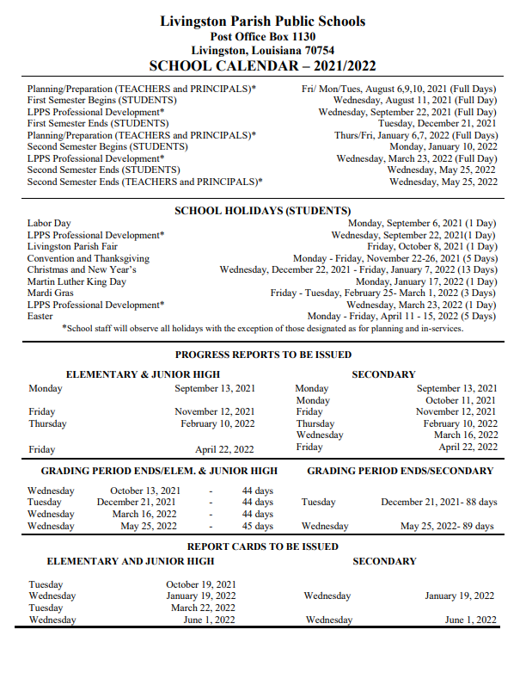
FAQ’S
What do I do if my child is late for school?
School begins at 7:55 a.m. If you arrive after 7:55 a.m. you are considered tardy. You will need to bring your child to the office and check them in. No student should come to the office without a parent. Once the student is checked in to school, we will make sure that the student makes it to class. Parents are not allowed to walk students to class.

What are the checkout procedures?
You will need to come to the office and sign your child out. The office will call your child to the front. Check outs will not be permitted after 2:30. This runs into our school preparing for dismissal.

What is considered a tardy or absences?
If you check in from: 7:55 – 10:30 = Tardy
10:31 – 12:30 = ½ day absence
After 12:30 = full day absence
If you check out from: 7:55 – 12:30 = full day absence
After 12:30 ½ day absence

How do I schedule a conference?
Call the office at 665-6702 to schedule a conference. Conferences are held from 7:30 – 7:50 a.m., Monday – Friday. Days may vary depending on the teacher’s duty schedule or grade level meeting day.

General Information
ADMISSION TO SCHOOL:
Kindergarten students entering Live Oak Elementary School must be 5 years old on or before September 30th of the school year in which they are enrolling. The DSC Assessment is administered to Kindergarten students before they enter school. At the time of registration, parents of all new students must present an up-to-date immunization record, student’s birth certificate, student’s social security card, current electric bill and 2 other proofs of residency. Place of residency must be the child’s primary residency. Students enrolling from other schools during the year must present a transfer slip and/or a copy of their most recent report card.

TRANSFER OF RECORDS:
When moving, a student must have all fees paid to Live Oak Elementary before records will be forwarded to another school. Please notify the school office at least one day prior to transferring so that a drop slip can be done and all records can be completed. Parents must come in to the office to sign the drop slip.

ATTENDANCE:
The school year consists of 177 days. Students must be in attendance 167 days to receive credit for the year’s work. Students are allowed no more than 10 unexcused absences for the year. If your child has 10 or more unexcused absences, he/she may be retained. In accordance with state law, only the following absences will be considered excused provided the parent and/or guardian sends an excuse to school confirming the reason for the absence the day the student returns:
- Personal illness (physical or emotional illness.)
- Serious illness or death in the immediate family.
- Emergency medical or dental attention.
- Observance of religious holidays of the child’s own faith.
Please remember that it is very important to get an excuse from your doctor for each visit. The excuse must contain the child’s name, date, days of the absence, and reason for the absence. The original doctor’s excuse must be sent to school. Faxed excuses will only be accepted from the doctor’s office. Please remind your child to let the teacher know they have an excuse. Students will receive 1 day to make-up work for each day absent.

PERFECT ATTENDANCE:
In order for a student to receive perfect attendance they cannot be tardy, checked out or checked in. This includes doctor appointments or emergencies.

ARRIVAL AND DISMISSAL:
School is in session from 7:55a.m. to 3:00p.m. Parents who transport students to and from school must enter the rear drive with the driver side of the car nearest the school. THE FRONT DRIVE IS RESERVED FOR BUS & DAYCARE TRAFFIC ONLY. Students are not allowed on campus prior to 7:30 a.m. and may not check out after 2:30 p.m. A student going home with another student as a car rider, must have a signed note from their parent or guardian. Someone from the office will call to verify this change. Students are not allowed to ride home with other students who are not on their bus route.
WALKERS:
At dismissal, Live Oak Elementary staff personnel will walk students to the entry of Live Oak Circle Subdivision. Students who walk to school should come straight to school and cross only at the designated cross walk. When it is raining during arrival and dismissal times, all walkers MUST go through the car rider line.
TARDINESS:
Prompt arrival at school is expected of all students. Late arrival disrupts class and causes loss of instruction time. Any student who arrives at school after 8:00 a.m. is considered tardy and must be accompanied to the office by a parent or guardian to secure an admission slip before entering class. According to school board policy, 6 tardies/check-ins in one semester will count as a ½ day absent.
CHECK-OUTS:
To check a student out of school, a parent or guardian must first go to the office and sign the check-out book (be prepared to show picture ID). Students checking out early must have a note from the parent if someone other than the parent comes to check them out. Notes should be given to the teacher as soon as school begins. The office will call the student’s parent to verify the note. All check-outs must take place before 2:30 p.m. Refer to the attendance section for those absences/checkouts which are excused.
BUS OPERATION POLICIES:
Parents or guardians are responsible for contacting the bus driver and keeping the teacher informed concerning bus numbers and any changes in transportation. In the event a bus should break down, a replacement bus will make the assigned load. Please send a written note to the teacher each time you plan to pick up your child at school. Discuss any problems occurring on the bus with the bus driver first. Continued abuse of bus privileges by a student will result in the denial of transportation. Due to overcrowding on our buses, no student may ride the bus home with another student. Parents are to come to the school office if there is a need to change transportation to and/or from school. You will be given an estimated time for pickup in the morning. Students need to be outside 10 minutes before this pick-up time to take into account for traffic.
PROCEDURES FOR CAR RIDERS:
Car riders will be assigned a numbered car tag. Please place the tag on the left side dash board or hang from the mirror. Enter the car rider line from Calmes Road by the field house and football stadium. Continue to drive around to the first opened gate. You will exit out the gate closest to Old La. Hwy 16. The gates are open from 7:30 to 7:53. If the gate is closed, you must drive to the front and bring your child in. If it is after 7:55, they are tardy and you will need to sign them in. For safety reasons we are asking that you do not drop your child off in the front and leave. You must accompany them inside.
EMERGENCY INFORMATION:
In case of an emergency, each student is required to have the following information on file in the school office.:
- Name of parent or guardian.
- Complete and up-to-date address.
- Up-to-date home, work and cell telephone numbers of parent or guardian.
- Information involving the current custody of a student needs to be on file in the office and updated as it changes.
- Emergency telephone numbers of relatives of friends.
- Physician’s name and telephone number.
- Medical alert information.
If a student becomes ill at school, and the parent or guardian cannot be contacted to check the student out personally, contacts listed on the student’s check-out card will be notified in order of appearance.
EMERGENCY DRILLS:
Fire drills and crisis management drills are conducted once a month. Severe weather drills are conducted as needed. Detailed escape routes are posted inside the door of each classroom and drills are practiced by the students.
CHANGE OF ADDRESS/TELEPHONE:
It is important that each student maintains a current address and telephone number record in the school office. Please notify the office in writing, in person if you have a change of address or telephone number at any time during the school year. You will also need to provide current proofs of the residency change.
TELEPHONE:
The office telephone is a business phone and is not to be used by students except in emergencies. Students are not allowed to use the phone to make personal arrangements (such as requesting permission to go home with another student.) Please do not call the school and ask for messages to be given to a student. Special arrangements should be made with your child before he/she leaves in the morning. Classes will not be disturbed to deliver these messages.
DELIVERIES:
Students are not allowed to receive deliveries at school. Examples are balloons, flowers, presents, etc. Please make arrangements for these to be delivered to the student at their home.
FEES:
The school charges a variety of fees for different materials, services and activities, such as copying supplies, grade level materials, and other student consumable supplies that support the curriculum. Fees should be paid promptly. Deadlines are set for payments and we require that you make those payments on or before that date. If a family has a financial problem which affects the payment of school fees, the situation should be brought to the attention of the administration in order for suitable arrangements to be made.
Grades | Supply Fee | Technology Fee | Cap and Gown
PreK, 1st, 2nd, 3rd, 4th | $30.00 | $5.00 | N/A
Kindergarten | $30.00 | $5.00 | $15.00

PAYING FEES ONLINE:
The following items that you will need to pay will be available online. This includes: supply fees, field trips, club fees, spirit shirts, yearbooks, fundraisers, and other activities as they come up.
You will need to create an account for your student.
To make payments, go to the link on the Live Oak Elementary School website https://osp.osmsinc.com/LivingstonLA/Default.aspx, or the Livingston Parish School Board website and select Online School Payments. This is where you will select what fee you want to pay and make your payments. If you have any questions or issues, please call the school office.
RETURNED CHECKS:
Livingston Parish School Board has selected Envision Payment Solutions as its check service provider.
What does this mean? If you have a check that is returned, it may be re-presented electronically. Also, in presenting a check for payment, you authorize service charges and processing fees to be debited from the same account should the check be dishonored. These fees, as permitted by state law, may be debited as a paper draft or an electronic funds transfer, at Envisions option. Each dishonored item is subject to the applicable state returned check fees.
Specifically, Per Louisiana Revised Statue Annotated §9:2782, the service fee for returned checks is $25 or 5% of face amount, whichever is greater. (Note that the fee structure will change according to any amendments made to LA law during a school year.)
If you wish to inquire about a returned check, please contact:
Envision Payment Solutions Tel: 877-290-5460 or 770-709-3100 Fax: 770-709-3007 P.O. Box 157 Suwanee, Ga 30096 customerservice@envisionpayments.com
FIELD TRIPS:
Field trips are an extension of what is being learned in the classroom. These may be scheduled two times a year per grade level. These trips are scheduled to supplement units of study undertaken by the students and to introduce them to the resources of our state and community. Parents will receive notice of field trips in advance. Students must ride the school bus to and from these events. If you will be chaperoning a trip, you will be expected to supervise a small group of students. Because of this, younger aged children may not attend field trips with parents who are chaperones. All school fees must be paid before a student will be permitted to attend any class field trip.
LOST OR DAMAGED TEXTBOOKS AND/OR LIBRARY BOOKS:
Textbooks are furnished by the state, bar-coded, and issued to individual students at the beginning of the year. Students who lose a book will be expected to pay for it. A fine will be charged for books damaged while checked out to an individual. The fine also applies to the removal of a barcode by a student. The same policy concerning lost or damaged textbooks also applies to library books.
STUDENT DRESS CODE
The policy of the Livingston Parish School Board shall be that no mode of attire shall be
considered proper for school wear that disrupts the classroom and/or the school's positive learning environment. In questions regarding student dress and grooming, the principal or his/her designee of each school shall make the final decision based on this policy as to what is considered proper or improper dress according to the guidelines provided. The Livingston Parish School Board is responsible for achieving a systemwide dress code for appearance and dress among students that will promote the best atmosphere for teaching and learning.

NOTIFICATION
The School Board shall notify the parent or guardian of each student of the dress code
specifications and their effective date. The dress code shall be distributed in written form or posted on the school’s website annually. If the School Board modifies the existing uniform policy, it shall notify, in writing the parent or guardian of each student of the policy adoption or uniform policy modification at least sixty (60) days prior to the effective date of the new or revised policy. Each school shall display any uniform selected for a reasonable period prior to the proposed effective date for wearing of the uniform. However, nothing shall prohibit the School Board from requiring a new or revised dress code or uniform policy without the required notice in the event of an emergency. For the purposes of this policy, emergency shall mean an actual or imminent threat to health or safety which may result in loss of life, injury, or property damage.

DRESS AND PERSONAL GROOMING
It is the responsibility of each student to use good judgment regarding appearance and
attire. Cleanliness shall be a basic consideration. Any complaint concerning a student's
dress and appearance shall be addressed by the particular school's administration. The
principal of the particular school shall make the final decision as to what is considered
proper attire and appearance. In the event that health and medical considerations for a
particular student requires an exception to the Dress Code, the principal of the particular
school shall determine that exception and make his/her faculty and staff aware of the
exception.

The following guidelines have been established regarding all students’ dress and
appearance:
1. Styles of dress and grooming never should be such that they represent a
collective or individual protest.
2. Appropriate footwear must be worn to school (no shower shoes, flip-flops).
3. Caps, hats, unprescribed glasses are not permitted.
4. Patches, decorations, slogans, symbols, tags, marks, or advertisements are
prohibited. (Examples: beer, cigarettes, drugs, obscene suggestions,
sexual connotations, political, etc.)
5. Earrings are allowed for students provided they are not a safety concern or
a distraction on campus.
6. Piercings, other than ears, are not permitted. Clear (concise stud only)
pierce hole fillers are allowed for nose rings.
7. Jewelry, including earrings, worn during the school day should be a size
and dimension that is not a safety concern or a distraction on campus.
8. Hair should be neat, clean, and out of the student’s eyes. Students should
have natural hair color. Extreme unnatural colors are not allowed.
Sculptured hair styles that include pictures, symbols, letters, numbers, or
hair curlers, rollers or excessively teased will not be permitted. Principals
have discretion if a hairstyle including accessories interferes with learning.
9. Neatly groomed facial hair is acceptable, including mustaches, beards and
goatees.
10. Tattoos that are vulgar, obscene, political, offensive or otherwise disruptive
to the school environment are not permitted and must be covered at all
times.
11. Foundation garments must be worn.
12. Dress during any period where uniforms are not required, such as special
event days, or for transferring students, shall be consistent with the intent
and spirit of the School Uniform Dress Code.

Dress Code in Special Classes
Students must follow the rules of appropriate dress as directed by the needs of special
classes (i.e. physical education, industrial arts, agriscience, etc.) due to safety concerns.

SCHOOL UNIFORM DRESS CODE
The School Board is permitted by state law to adopt dress codes mandating the use of
school uniforms. The purpose of the School Uniform Dress Code shall be to provide
additional opportunities for increased school safety; to encourage students to experience a greater sense of school identity and belonging; to encourage an improvement in student behavior; and to encourage a high level of program participation.
Grades Pre-Kindergarten - 12:
Note: A color chart for skirts/shorts/slacks/skorts will be displayed to clarify the color range of Khaki.
Shirt:
• Solid color: Navy blue or white.
• Polo: (golf-boxed, hemmed) two, three or four buttons at the top front with collar (Short or Long sleeves) - Elementary students shall be encouraged to tuck in shirts. Middle/Junior High and High school students shall be required to tuck in shirts.
• Oxford/dress shirt (short or long sleeves) Elementary students shall be encouraged to tuck in shirts. Middle/Junior High and High school students shall be required to tuck in shirts.
• Designs, emblems, insignias, monograms and logos are prohibited.
• Under-shirts and t-shirts, if worn must be white, gray or black and can only be worn underneath the standard uniform.
• If applicable, school issued spirit shirt may be worn in place of the uniform polo on designated day set by the principal. Shall not exceed one time per week.
Pants, Skirts, Shorts, Skorts, Jumpers:
• Solid color: Khaki
• No jean, knit, jegging, stretch, cargo, capri, or cropped styles.
• Appropriate fit: not too loose, not too tight; no sagging.
• Elementary students may have elastic waist pants with or without belt loops (belts are optional, but encouraged).
• Middle/junior/high school students’ pants must have belt loops and a belt is mandatory. Must be worn at waistline,
• Skirts should be to top of kneecap.
• Jumpers should be to top of kneecap; not allowed for 9-12.
• Shorts/Skorts: Top of knee to four (4) inches above knee; length cannot be below the knees; length can be cuffed or not cuffed,
• The only logos allowed should be the manufacturer’s label.
• All bottoms must be hemmed.
Belts:
• PK-5: Belts are not required, but encouraged.
• Grades 6-12: Belt required with clothing designed with belt loops, any color, no inappropriate logos or slogans. Belts are to be worn correctly and buckles are not to be excessive size or offensive in design. Studs and spikes are prohibited.
Socks/ Hose/Tights: If worn...
• Socks may not have inappropriate or offensive wording or images. Socks above the knee are prohibited.
• Tights/Leggings solid color black, gray, navy blue or white (May only be worn under skirts/dresses/jumpers). Tights must be full length reaching the ankle.
Pullovers:
• Solid Navy blue or White (¾ zip, crew, hoodies, sweaters) are allowed. A pullover cannot be worn in place of shirt nor be so large that it conceals a student’s bottom garment. Designs, emblems, insignias, monograms and logos are prohibited
• Any spirit pullover purchased from the school or a vendor with the school name or logo is acceptable.
Shoes:
• Closed-toe and closed-heel shoes are mandatory (tennis shoes, dress shoes, casual shoes or slip-on shoes or boots).
• Footwear shall not extend above the knee
Shoes shall be properly tied or strapped, if applicable.
Coats:
• Coat/jacket/sweater may be worn as long as the uniform shirt collar is revealed under the coat/jacket/sweater (trenchcoats are prohibited)
• Vests/jackets/sweaters/coats that zip/button/snap from top to bottom may be any color and with hood. In schools with multiple grade levels, the principal shall be given the opportunity to determine where the breaks would be allowed on these issues (Example: K-12 Maurepas – the principal would have the opportunity to decide where the break would be to determine elementary, middle/junior high, and high school to best adapt to that school’s structure.)
Student Compliance with the Uniform Dress Code: The School Uniform Dress Code of Livingston Parish shall strive to achieve full compliance through use of incentives and positive reinforcement measures, and will resort to disciplinary action only when positive measures fail to ensure compliance. In addition, the policy's rationale and benefits of the School Uniform Dress Code will be explained and fully understood by the student and his or her family. The intent of this policy is not to inhibit or prohibit any student who is not in uniform from receiving the education to which he or she is entitled. Also, the intent of this policy is not to suspend or expel a student from class or from school, or lower an academic grade as a result of not complying with the School Uniform Dress Code. However, non-compliance shall result in progressive disciplinary action being taken with the student. No student shall be considered in violation of the School Uniform Dress Code in the following instances:
A. When administrators allow exceptions to the uniform code for special events. (Ex. Dress-up day, athletes on game days, band, cheer, academic teams, clubs, picture day, band on regular meeting days, etc.)
B. During the first ten (10) school days after transferring from out of the Parish to Livingston Parish Schools. During this ten (10) day period, appropriate dress (according to School Board Policy) shall be followed.
C. When a student is on campus outside of normal school hours.
SMOKE FREE CAMPUS:
Students shall not be permitted to have in their possession any tobacco or tobacco products, any combustible plant material, any form of smoking object or device, including electronic cigarettes or similar devices, in any elementary or secondary school building, school bus or vehicle, or any Livingston Parish School Board building or facility, or on the campus of any elementary or secondary school property or any other School Board property, or at any school-related activities. School Board property shall include any portable buildings, field houses, stadiums, equipment storage areas, vacant land, or any property owned, operated, or leased by the School Board where any form of School Board business is or may be conducted. Parental permission to smoke does not exempt a student from this policy. Violations shall subject the student to appropriate disciplinary action.
DRUG FREE CAMPUS:
DRUG FREE ZONES It is unlawful for anyone to use, distribute, be under the influence of, manufacture or possess any controlled substances as defined by statute on or around school property or an area within 2,000 feet of any property used for school purposes by any school, or on a school bus. These areas shall be designated as Drug Free Zones. The Livingston Parish School Board, in cooperation with local governmental agencies, and the Louisiana Department of Education, shall designate and mark Drug Free Zones which surround all schools and school property.
POSITIVE BEHAVIOR AND INTERVENTION SUPPORTS (PBIS):
PBIS is an evidence-based, data driven framework proven to reduce disciplinary incidents, increase a school’s sense of safety, improve school climate, and support improved academic outcomes for all students. It is a tiered support system where the entire school staff arranges an effective learning environment that helps students work toward self-management of their own behavior and academic outcomes.
The students at Live Oak Elementary will learn to follow the acronym SOAR – Safety, Ownership, Achievement, and Respectful in all areas that they visit on campus. Our goal is for every student to SOAR while at LOE.
PBIS ACTIVITY DAYS:
Students displaying appropriate behavior will be allowed to participate in LOE PBIS Days throughout the year. We will have a PBIS day at the end of each month. Students who qualify for the PBIS day, will receive a notification with the details of what they can wear or bring to school.
DISCIPLINE:
In order to guarantee all students are able to participate in a positive and challenging educational climate they deserve, teachers have the authority and responsibility to maintain discipline in the classroom. Every classroom will follow the same school-wide rules, so all students know the same expectations for every classroom or area in which they visit.
In order to handle problems that arise, the teacher may hold a conference with the student, call a conference with the parent or guardian, use classroom disciplinary procedures, or refer the situation to the principal. To ensure consistency in discipline throughout the school, the following guidelines will be used:
1st offense – Warning
2nd offense – Warning with behavior mark
3rd offense – Silent lunch
4th offense – Recess detention
5th offense – Referral to the office

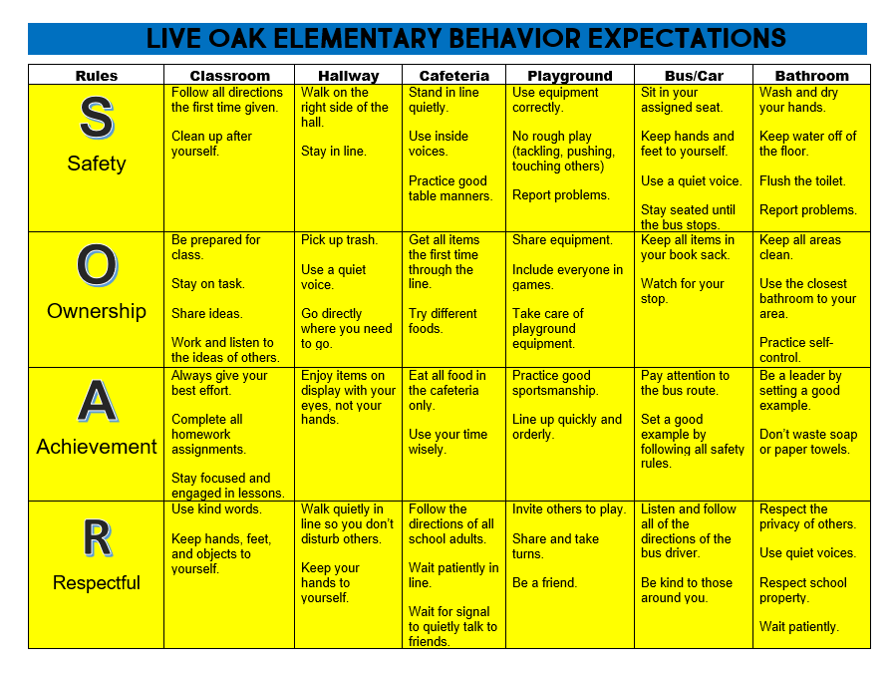

SUSPECTED CHILD ABUSE If the victim of the alleged sexual misconduct is a minor student and if the alleged misconduct falls within the definition of abuse as found in School Board policy JGCE, Child Abuse, then all school employees with knowledge will be considered mandatory reporters and the allegations must be reported to child protection or law enforcement as provided by state law and School Board policy. Such reporting must be made in addition to any procedures for handling sexual misconduct complaints.
LOST AND FOUND
Clothing items that are found in the school campus will be placed in the lost and found. Money, jewelry, and other items of value are turned into the office. Students may claim lost items after giving proper identification. Any items that are not claimed by the end of the school year will be donated to a local charity.

CAFETERIA
All students will be eligible for free breakfast & lunch throughout 2021 – 2022. We will be serving Grab & Go breakfast items daily for all students. While students are in the cafeteria, the following rules are to be obeyed:
- There is to be no breaking in line. Students are to come to the cafeteria in lunch order.
- Students are responsible for cleaning the area around them before leaving the lunchroom.
- No food or drink is to be thrown. Canned or bottled soft drinks are NOT allowed. Fruit juices are allowed. This is a state policy.
- Students should be quiet while walking to and from the lunchroom.
- Food packaging with printed names/logos from commercial food establishments (McDonald’s, Burger King, Sonic, etc.) is prohibited during meal service.
LUNCH WITH STUDENTS
Parents may eat with their child when he/she is Student of the Week, Elite Eagle or celebrating their birthday. We also have a designated day for each grade level to have lunch with their families. Information on those days will come to you through the year when it is your grade levels turn.
RECESS
Students enjoy recess each day, weather permitting. No student will be allowed to remain in the classroom without a note from their physician. Students may purchase chips, water, and other items during their afternoon recess. Prices range from .50 to $1.00.
PARENT VOLUNTEERS
Parent and grandparent volunteers are special resources at our school. Please call the school office to volunteer if you have time and skills you can share to make our school a better place for students to grow and learn. Parents who work are also welcome to participate in the VIPS (Volunteers in Public Schools) Program. Volunteers must check in and out at the office and wear a visitor’s tag.
VISITORS
Visitors who enter the school must first report to the office where they will sign in and then be given a visitor’s badge to wear. This badge must be visible during the entire visit at school. Visitors are not to go to the classroom unless prearranged with their child’s teacher. Teachers are not to be disturbed during instruction time which is from 7:55 – 3:00.

PARTIES
Parties are held at Christmas and Easter. These are special times for students therefore, we ask that no preschool children attend. Please honor this request. Birthday treats may be brought to school for student birthdays. Please make arrangements with your child’s homeroom teacher. Students are not allowed to receive gifts, flowers, or balloons at school.
FUNDRAISERS
Fundraisers are very important to the school. We have two major fundraisers that we encourage all families to participate in. We also have additional fundraisers throughout the year for certain organizations such as the United Way, March of Dimes, etc. In addition, by saving Community Coffee UPC labels, Campbell’s soup, Box Tops and subsidiary product labels we receive school rewards that allow us to opportunity to purchase much needed teaching materials for our students. Please participate if you are able to do so.
THE LOE NEWSLETTER AND CALENDAR
A school newsletter containing a monthly calendar and information of interest to students and parents will be distributed the first of each month. Please post it in a handy place for reference throughout the month.
YEARBOOK
A yearbook will be available for purchase by students and parents. Photographs and articles are assembled throughout the school year. Delivery will be at the end of the school year. Yearbooks must be ordered in advance.
GRADING
Interim reports are issued at 4 ½ weeks intervals between report card periods. Report cards are issued at the end of each nine week’s period. The report card may be kept, but the report card paper must be signed and returned to the teacher as soon as possible to acknowledge the receipt of grades.
KINDERGARTEN GRADING
Kindergarten students will not receive an interim until the second nine weeks, but will receive the 1st – 9 weeks LPPS Report Card. Student’s progress on Kindergarten report cards is denoted by this alphabetical system: “E” for Excellent “S” for Satisfactory
“N” Needs Improvement
“U” for Unsatisfactory

FIRST GRADE THROUGH FOURTH GRADE GRADING SYSTEM
The following parish-wide grading scale will be used for grades 1 – 4:
100 – 93 = A
92 – 85 = B
84 – 75 = C
74 – 67 = D
66 – 0 = F

CONFERENCES
Parent-teacher conferences may be scheduled by calling the school office at (225)665-6702. Conferences are held from 7:30 – 7:50 a.m., Monday through Friday. Days may vary depending on duty schedules of individual teachers.
STUDENT USE OF PERSONAL ELECTRONIC DEVICES
No student, unless authorized by the school principal or his/her designee, shall use (must be in the off position), make visible, or operate any personal electronic device including any device in a student’s possession that electronically communicates, sends, receives, stores, reproduces or displays voice and/or text communication or data on any elementary, middle, or secondary school grounds or any bus while being transported to and from school or any school functions. The devices shall include, but are not limited to, cellular phones, smart phones, e-Readers, iPods, SPY Pens, Pocket Audio Key Chains, audio flash drives, smart watches, cameras, video recorders and personal GPS tracking devices with audio features. Neither the Livingston Parish School Board nor any individual schools under the jurisdiction of the School Board shall be held responsible for lost, stolen, confiscated, or damaged electronic devices.
- Students in Grades PK – 5
Personal electronic devices shall not be permitted on campus during regular school hours for any reason for students in PK – 5th grades.

LIVINGSTON PARISH PUBLIC SCHOOLS HEALTH RULES
The following guidelines are offered to help you determine when your child should not attend school. Please consider carefully a child’s statement of feeling ill.
SCHOOL NURSE
The school nurse is responsible for the maintenance of health records, routine health checks, parental contact concerning health problems, care of minor injuries, vision and hearing screening, and assistance in health teaching. Please contact the school nurse if your child is absent from school due to an illness / disease.
- Diarrhea/vomiting: Students who are vomiting or have diarrhea (2 or more watery stools) will be sent home from school. They will not be allowed to return until they are symptom free for 24 hours from the onset of symptoms. Children should be kept home if they were vomiting or experienced diarrhea during the night.

- Fever: Students who have a fever >100 F orally or higher will be sent home. Students will be readmitted after they have been fever free for 24 hours without the use of fever reducing medications (Tylenol, Motrin, Advil).

- Cold/Flu: Students with severe colds, sore throats, cough or “flu like” symptoms will not be allowed to stay at school. They should stay home for rest and proper attention to their symptoms.

- Pink Eye: Symptoms of pink eye such as eye drainage, crusty eyelids, redness of whites of eyes, swelling, and itching may indicate pink eye, which is a contagious disease. Children with these symptoms will be sent home and should be seen by a doctor for a diagnosis. If they are diagnosed with pink eye they must be on treatment for at least 24 hours before they can return to school. A doctor’s excuse will be required for them to return to school. Some conjunctivitis may require the student to remain at home until all symptoms are resolved.

- Rash/Lesions: A student with an undiagnosed rash or lesion will not be allowed to stay at school. Skin lesions or rashes will be considered possibly contagious. Child may return to school after rash is determined to be non-contagious by a physician or to be no longer contagious after proper treatment. Students may return with a note from the Physician’s office.

- Boils: Students with boils must be seen by a physician. If it is a staph infection, they must remain home for 24 hours after starting antibiotics. A physician’s note will be required for them to return to school. The boil must be covered. If the boil is draining, extra clothes and bandages should be sent with the student in case the bandage becomes saturated or if the clothes get wet.

- Lice: A student’s hair must be free of nits and bugs in order to remain at school. The student will be readmitted to school after the parent has treated the child and all nits and bugs are removed. After successful treatment, the parent will need to bring the student to the office to be rechecked for lice by school personnel before being allowed to stay at
school. It is recommended that parents check their child on a regular basis for signs of head lice.

- Medication: If your child needs to take medications for chronic conditions at school please contact your school nurse. State law requires a medication administration form be completed by the physician and parent. This includes prescription and over-the-counter medications. If a student is prescribed a new medication, they must remain at home for 12 hours after the first dose to be observed for adverse reactions. Parents are allowed to bring medications to the school and administer them to their child. If Parents cannot come, they may send the medication with someone listed on the child’s contact card. If the parent or someone on the contact card cannot come then the parent may send an adult not listed on the contact card. The school will require a written or verbal consent for the parent if the adult is not on the contact card and an ID will be checked.

- Immunizations: Louisiana State Law Statute LA R.S. 17;170

Students entering school for the first time shall present a completed or up to date immunization record.

All students that are 11 years old must have a Tdap Booster, Meningitis vaccine, and a second Varicella (chickenpox). Students that are 16 years of age must have a second meningitis immunization.

Parents of students that are unable to receive their immunizations due to medical, religious, or personal reasons must submit a written letter of dissent. This letter can be found on the LDOE and LPPS websites.

Students that have not received proper immunizations may not be allowed to come to school if there is an outbreak of a communicable disease at school (Chickenpox, Measles, Pertussis, etc.) State law must exclude these students from the school setting, for the incubation period of the disease. These absences may not be excused.

- Vision/Hearing: Student’s vision and hearing are screened by the school nurse in Pre-K, KN, 1st, 3rd, 5th, 7th, and 9th grades and from parent or teacher referrals. If a problem is detected, notes will be sent home to the parent referring them to their physician for a more complete evaluation.

- Scoliosis: Students are screened in 6th grade for curvature of the spine. If signs are seen, students will be sent home with a letter referring them to their physician for a more complete evaluation.
- Medical Conditions: If your child has a chronic medical condition, contact the Nurse at your school, annually. Some examples of chronic medical conditions are: Seizures/Epilepsy, diabetes, asthma, celiac disease, severe allergic reactions to insects or food that require use of an Epipen or Benadryl during the school day. A SPECIAL DIET ORDER form is required annually from a physician if your child has specific food allergies.

- Post – Surgery or Hospitalization: If your child is hospitalized or has surgery, he/she must return with a note from the physician allowing him/her to return to school. Any restrictions must be noted on the return to school form.
If you have any questions or concerns, you may call Jennifer Wilkinson, RN School Nurse Coordinator at (225) 686-4368 or contact the school nurse at your child’s school.
In order for proper care to be provided at school, it is the parent’s responsibility to notify the school nurse with any medical conditions or needs your child may have; including any changes to their medical conditions during the school year.
PLEASE LET MY SCHOOL NURSE KNOW IF:
I HAVE  A FEVER | I  AM VOMITING | I  HAVE DIARRHEA | I HAVE  A  RASH | I HAVE  HEAD  LICE | I HAVE  AN EYE  INFECTION | I HAVE  BEEN IN  THE  HOSPITAL
Temp of 100⁰ or  Higher. | Within the  past 24  Hours. | Within the  past 24  Hours. | Body rash with itching or fever. | Itchy head, active head lice. | Redness, itching, and/or pus draining from eye. | Hospital stay and/or emergency room visit.

I am ready to go back to school when I am …
Fever free without the assistance of medication for 24 hours (i.e. Tylenol, Motrin, Advil). | Free from vomiting for 24 hours. | Free from diarrhea  for 24 hours. | Free from rash, itching, or fever. I have been evaluated by my doctor if needed. | Treated with appropriate lice treatment at home. | Free from drainage and/or have been evaluated by my doctor if needed. | Released by my medical provider to return to school.
If your child has strep throat or another bacterial infection, he/she should stay home until the antibiotic has been given for at least 24 hours and your health care provider has given permission for your child to return to school. We encourage you to seek medical attention when your child is sick and to follow your health care provider’s recommendations about returning to school and other social activities.
Live Oak Elementary School Nurse: Karin Burnett, CSN, RN Email: Karin.burnett@lpsb.org

IMMUNIZATION INFORMATION
The Office of Public Health requires the following age appropriate immunizations your child must receive before attending school.
Pre-K and Kindergarten
4 or 5 – Tetanus, Diphtheria, Acellular pertussis Vaccine (Tdap) (last dose must be administered after the child’s 4th birthday)
2 – Varicella (The Varicella Vaccine is waived if the student has had a history of the Chickenpox disease. The parent is responsible for reporting the case of chickenpox to the school nurse, or local health department.)
2 – Measles, Mumps-rubella (MMR)
3 – Hepatitis B (HBV)
3 or 4 – Polio (IPV) (Last dose must be administered after the child’s 4th birthday)

LICE SCHOOL BOARD GUIDELINES
Livingston Parish Public Schools will exclude any student suspected of having symptoms of head lice until satisfactory treatment has been given. The student shall be re-admitted to school after the parent or guardian has treated the child, and all lice and eggs have been removed. Students who have been treated for lice must be brought to school by the parents and re-checked by school personnel before they are allowed to return to class. It is recommended that you check your child on a regular basis for signs of head lice. You can find information on head lice on the LPPS website and the internet.

MEDICATION GUIDELINES
Livingston Parish Public Schools require the following forms must be on file in your child’s health records BEFORE we begin to give any medicine at school.
- Signed authorization form by the parent or guardian to give medicine.
- Signed medication order. The written order form should be taken to your child’s licensed prescriber (your child’s physician or dentist) for completion and returned to the school office. This order must be renewed if there are any changes in dosage, time, or medication and also at the beginning of each school year.
- Medicine should be delivered to the office either by you or a responsible adult whom you designated (never the student). It must be in a container with a label from the pharmacy. Please ask your pharmacy to provide a separate bottle for school and home use. No more than a thirty-five day supply of the medicine should be delivered to the school. The parent or guardian is responsible for picking up the empty medicine bottle. The student will not be allowed to carry the container home.
- No “over the container” medication such as Tylenol, aspirin, cough medicine, etc. can be given at school without a doctor’s order and a prescription label. When your child needs medicine to be given during the school day, please act quickly to follow these policies so that we can begin giving the medicine as soon as possible.
- If a student is prescribed a new medication, they must remain at home for 12 hours after the first dose to be observed for adverse reaction.
WHENEVER POSSIBLE, MEDICATION SHOULD BE GIVEN AT TIMES OTHER THAN SCHOOL HOURS.
SPECIAL NEEDS STUDENTS
It is the policy of the Livingston Parish School Board and LOE to provide a free and appropriate education to each special needs student within jurisdiction, regardless of the nature of the special need. Each student with special needs will be educated in accordance to their Individualized Educational Plans (IEP).

LIVINGSTON PARISH PUBLIC SCHOOLS FAMILY RESOURCE CENTER
The goal of the Family Resource Center is to provide resources that will assist, guide, support, and engage families with their children’s education.
The LPPS Family Resource Center lending library is located in Room 165 at the Livingston Parish Literacy and Technology Center 9261 Florida Boulevard Walker, La. 70785
Please feel free to contact us at (225) 667-1098 or e-mail: Jennifer.rabalais@lpsb.org

LIVINGSTON PARISH SCHOOL BOARD STUDENT ACCEPTABLE USE TECHNOLOGY POLICY
NETWORK USAGE: Students are responsible for good behavior on school computer networks just as they are in a classroom or a school hallway. Communications on the network are often public in nature. General school rules for behavior and communications apply. The network is provided for students to conduct research, complete assignments, and communicated with others. Independent access to network services is provided to students who agree to act in a considerate and responsible manner. Access is a privilege, not a right. Access entails responsibility. Network storage areas may be treated like school lockers. Network administrators may review files and communications to maintain system integrity and insure that users are using the system responsibly. Users should not expect that files stored on district servers will always be private. During school, teachers of younger students will guide them toward appropriate materials. Outside of school, families bare responsibility for such guidance as they must also exercise with information sources such as television, telephones, movies, radio and other potentially offensive media.
The following are not permitted:
1. Sending or displaying offensive messages or pictures.
2. Using obscene or offensive language.
3. Giving personal information when using the system, such as complete name, address, phone number and identifiable photo without permission from teacher and parent or guardian.
4. Unauthorized downloading and installation of software.
5. Harassing, insulting or attacking others.
6. Damaging computers, computer systems or computer networks.
7. Violating copyright laws.
8. Hacking, vandalism and unauthorized access.
9. Using others’ password. 10. Trespassing in others’ folders, work or files. 11. Intentionally wasting network resources.
12. Employing the network for commercial purpose, financial gain, or fraud.
13. Students using proxy services to by-pass/circumvent internet filtering are in violation of all the Intent of Internet use standards and will be dealt with as such by the principal. This violation will result in loss of access.

Sanctions
Violations may result in a loss of access. The range of sanctions is identified in the Discipline Policy. Additional disciplinary action may be determined at the building level in line with existing practice regarding inappropriate language or behavior. When applicable, law enforcement agencies may be involved and may result in prosecution and/or restitution for damages.
Permissions
The Acceptable Use Policy will be distributed to students and parents through the school handbook, and will be posted on the school board website. Parent permission will be assumed unless specifically denied. Parents must go to the school and sign a “Denial of Permission Form”.
Parental permissions that are assumed include:
- Access to the internet and email system
- Permissions to publish students’ work to classroom websites
- Permissions to have unidentified photos of students published to classroom websites.
Denial of Permission
As a parent or legal guardian, if you would like to deny your student access to the internet, you will need to come to school to sign this denial with the principal.

Livingston Parish Public School System
Title I Family Engagement Policy
2021-2022

A Districtwide Family Advisory Council has been established in order to revise the current Livingston Parish Title I Parent and Family Engagement policy and expand the plan in accordance with the Every Student Succeeds Act (ESSA) of 2015, section 1112 of the Elementary and Secondary Act (ESEA). This council will meet regularly in order to coordinate and integrate family involvement, and evaluate the effectiveness of the policy. This policy will be made available to the local community and updated periodically to meet the changing needs of the families and the school. The ultimate goal is to ensure that all families within the district are provided the same opportunities for involvement in their child’s education. The advisory council will also be informed of the process of the 1% of Title I, Part A funds reserved for family engagement. The Local Education Agency (LEA) will incorporate these ideas into the district-wide policy. If there are any unsatisfactory comments on the plan, these will be forwarded to the State Education Agency (SEA).

Under the direction and technical assistance of the Local Education Agency (LEA), each Title I school will have family members serve on the Schoolwide Committee, which will function to review the schoolwide plan and family activities for that school. This plan will be specific to the Title I school and will provide a means for families to become more involved in their child’s education.

Consistent with section 1118 of the ESEA, an annual meeting will be held in each school in which family members will be given information about their school participation in the Title I program and related services, an explanation of the requirements of this participation and a school/family compact as required by section 1118(d) of the ESEA. Family members will also be informed of their right to parent-teacher conferences, regular reports on their children’s progress, reasonable access to staff, opportunities to volunteer on campus, and to request information regarding the professional certifications of their student’s classroom teachers. To the extent, which is practical, meetings will provide full opportunities for the participation of family members with limited English, members with disabilities and migrant parents following section 1111 of the ESEA. Information will be understandable and uniform.

One goal of this plan will be to improve communication between home and school through family/school compacts, newsletters, family-teacher conferences, handbooks, agendas, surveys, School Messenger recordings, electronic communications, such as: telephone calls, texts and emails, and school social media types of sharing information. It is important that family members respond to communications from the school in a timely manner and talk with their children about their classroom activities and behavior.

Another goal will be to provide information concerning the Every Student Succeeds Act (ESSA) of 2015, the State of Louisiana Accountability Law, the curriculum used at the school, the forms of academic assessment used to measure student progress, and the proficiency levels students are expected to meet.

Title I schools will assist families with parenting skills, technology skills, and give assistance in helping with homework, projects, and other at-home activities. Families will be encouraged to take advantage of teacher conferences as a way of monitoring the progress of students. Schools will also provide opportunities for the local community to become more involved with families and with the school.

Family participation is essential to the success of the students. By monitoring the child’s progress and working with educators to improve students’ achievement, families provide a vital link between the school and the student. Students should know that their family values education and achievement and are available to help them to achieve their goals. Annually, each school will disseminate and collect family surveys to improve engagement. Results from the survey, if needed, will be used to revise family engagement policies at the school level.

It is Livingston Parish Public School System’s goal to reach out to, communicate with and work with families as equal partners in our schools.

Livingston Parish Public School System
Title I Family Engagement Policy
(Politica de Participación Familia)
2021-2022

Un Consejo Asesor Familia ha sido establecido por el distrito con el fin de revisar la actual política de Livingston Parish Title I Family Engagement (Participación de la Familia) y ampliar el plan de conformidad con el Every Student Succeds Act (ESSA) of 2015. Este Consejo se reunirá periódicamente con el fin de coordinar e integrar la participación de la familia y para evaluar la eficacia de la política. Esta política se pondrá a disposición de la comunidad local y será actualizada periódicamente para satisfacer las necesidades cambiantes de los padres y la escuela. El objetivo final es garantizar que todas las familias dentro del distrito sean proveídas de las mismas oportunidades de participación en la educación de sus hijos. El consejo asesor también será informado del proceso de los fondos del 1% del Título I, Parte A, Los Fondos Reservados para la Participación de los Padres-Familia. La LEA incorporara estas ideas dentro de la política de todo el distrito. Si hay algunos comentarios no satisfactorios en el plan, éstos se remitirán a la Agencia Estatal de Educación (State Education Agency/SEA, por sus siglas en ingles).

Bajo la dirección y la asistencia técnica de la Agencia Local de Educación, cada escuela Título I tendrá miembros de la familia sirviendo/ejerciendo en el Comité de la Escuela, que funcionará para revisar el plan de toda la escuela y las actividades de los padres de esa escuela. Este plan será específico a la escuela de Título I y proporcionará un medio para que padres-familia se involucren más en la educación de sus hijos.

Una reunión anual se llevará a cabo en cada escuela en la que se les dará a los padres información sobre la participación de su escuela en el programa Título I y los servicios relacionados, y una explicación de los requisitos de esta participación. Los miembros de la familia también serán informados de su derecho a las conferencias entre padres y maestros, informes periódicos sobre el progreso de sus hijos, el acceso razonable al personal, oportunidades para ser voluntario y participar en la clase de su hijo, y para solicitar información sobre los títulos profesionales de los maestros de sus hijos. En la medida de lo práctico, las reuniones de padres brindarán oportunidades para la participación de los miembros de la familia con inglés limitado, miembros de la familia con discapacidades y padres migrantes. La información será comprensible y uniforme.
Uno de los objetivos de este plan será el de mejorar la comunicación entre el hogar y la escuela mediante acuerdos entre padres-familia/escuela, boletines informativos, conferencias entre padres y maestros, manuales, agendas, encuestas, mensajes vía School Messenger Phone System, comunicaciones electrónicas tales como: llamadas telefónicas, mensajes de texto y correos electrónicos y otros tipos de intercambio de información. Es importante que los padres respondan a las comunicaciones de la escuela de una manera oportuna y que hablen con sus hijos sobre sus actividades en el aula.

Otro objetivo será proporcionar información acerca del Every Student Succeeds Act (ESSA) of 2015, la Ley de Responsabilidad del Estado de Louisisana (State of Louisiana Accountability Law), el currículo usado en la escuela, las formas de evaluación académica utilizadas para medir el progreso del estudiante, y los niveles de competencia que se espera que los estudiantes cumplan.

Las escuelas Título I asistirán a las familias con las habilidades de crianza, habilidades tecnológicas, y darán asistencia para ayudar con las tareas, proyectos y otras actividades en el hogar. Los padres serán animados a tomar ventaja de las conferencias entre padres y maestros como una forma de monitorear el progreso de los estudiantes. Las escuelas también proporcionaran oportunidades para la comunidad local al involucrarse más con las familias y con la escuela.

La participación de familia es esencial para el éxito de los estudiantes. Al monitorear el progreso del niño/a y trabajar con los educadores para mejorar los logros de los estudiantes, los padres proporcionan un vínculo vital entre la escuela y el estudiante. Los estudiantes deben saber que sus de familia valoran la educación y los logros y están disponibles para ayudarles a alcanzar sus objetivos. Anualmente, cada escuela difundirá y recogerá encuestas de familia para aumentar la participación de la familia. Los resultados de la encuesta, si es necesario, se utilizarán para revisar las políticas de participación de familia en el ámbito escolar.

Es la meta del Sistema de Escuelas Públicas del Condado de Livingston (Livingston Parish Public School System) lograr comunicarse y trabajar con familias en condiciones de igualdad en las escuelas.

Google Classroom

This year, Google Classroom will only be used as a place for makeup work, if the teacher decides to use it in grades 2-4. Should your child become sick, and will be out for an extended amount of time, please contact the office, and we will collect work for a family member to pick up.

The next page will contain the common logins that we use for programs at Live Oak Elementary.

